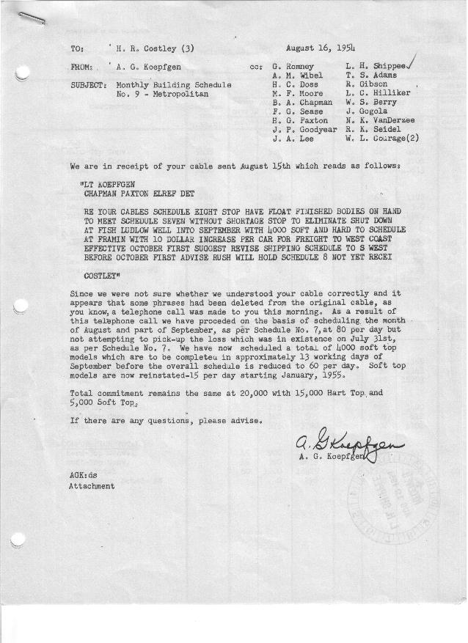

FORM PLAN 68 REV. 9-40-N.K.P PRINTED IN U.S.A

SCHEDULE NO. ______9_________ DATE August 16, 1954 MONTHLY BUILDING SCHEDULE APPROVED F. G. Sease & W.L. Courage (signed)_____DATE 8-17-54 & 8-18-54 REVISION NO. ________________ DATE ________________ PRODUCT APPROVED_____B. A. Chapman (signed) ___________DATE_ _8-17-54____ ___
METROPOLITAN SERIES CARS – AUSTIN MOTOR CO., LTD., ENGLAND

DESCRIPTION | BUILT  ◻ACT◻ EST  THRU  7-31-54 | FIRM BUILDING SCHEDULE  (FABRICATED MATERIAL RELEASE) |  |  |  |  |  |  |  |  |  |  |  |  |  |  | TENTATIVE SCHEDULE  (RAW MATERIAL RELEASED) |  |  | GRAND  TOTAL
DESCRIPTION | BUILT  ◻ACT◻ EST  THRU  7-31-54 | MONTH August, 1954  DAYS 12 (10 days down) |  |  | MONTH September  DAYS 22 |  |  | MONTH October  DAYS 21 |  |  | MONTH November  DAYS 22 |  |  | MONTH December  DAYS 23 |  |  | MONTH January, 1955  DAYS 21 |  |  | GRAND  TOTAL
DESCRIPTION | BUILT  ◻ACT◻ EST  THRU  7-31-54 | DAILY | MONTH | CUM’L  TOTAL | DAILY | MONTH | CUM’L  TOTAL | DAILY | MONTH | CUM’L  TOTAL | DAILY | MONTH | CUM’L  TOTAL | DAILY | MONTH | CUM’L  TOTAL | DAILY | MONTH | TOTAL | GRAND  TOTAL
NASH
Hard-Top Conv. | 5438 |  | 530 | 5968 |  | 845 | 6813 |  | 667 | 7480 |  | 909 | 8389 |  | 946 | 9335 |  | 655 | 9990
Soft-Top Conv. | 3700 |  | 0 | 3700 |  | 0 | 3700 |  | 0 | 3700 |  | 0 | 3700 |  | 0 | 3700 |  | 210 | 3910
Total | 9138 |  | 530 | 9668 |  | 845 | 10513 |  | 667 | 11180 |  | 909 | 12089 |  | 946 | 13035 |  | 865 | 13900
HUDSON
Hard-Top Conv. | 220 |  | 322 | 542 |  | 650 | 1192 |  | 593 | 1785 |  | 411 | 2196 |  | 434 | 2630 |  | 290 | 2920
Soft-Top Conv. | 71 |  | 108 | 179 |  | 121 | 300 |  | 0 | 300 |  | 0 | 300 |  | 0 | 300 |  | 105 | 405
Total | 291 |  | 430 | 721 |  | 771 | 1492 |  | 593 | 2085 |  | 411 | 2496 |  | 434 | 2930 |  | 395 | 3325
CORPORATION - TOTAL
Hard-Top Conv. | 5658 | 71 | 852 | 6510 |  | 1495 | 8005 | 60 | 1260 | 9265 | 60 | 1320 | 10585 | 60 | 1380 | 11965 | 45 | 945 | 12910
Soft-Top Conv. | 3771 | 9 | 108 | 3879 |  | 121 | 4000 | 0 | 0 | 4000 | 0 | 0 | 4000 | 0 | 0 | 4000 | 15 | 315 | 4315
Grand Total | 9429 | 80 | 960 | 10389 | * | 1616 | 12005 | 60 | 1260 | 13265 | 60 | 1320 | 14585 | 60 | 1380 | 15965 | 60 | 1260 | 17725
Over/(Under) Sched. #8 | 0 | 0 | 0 | 0 |  | 296 | 296 |  | 0 | 296 |  | 0 | 296 |  | 0 | 296 |  | 0 | 296
* 80/day 13 days
60/day 9 days
 |  | MONTH February  DAYS 20 |  |  | MONTH March  DAYS 23 |  |  | MONTH April  DAYS 3 |  |  | Grand  Total
NASH
Hard-Top Conv. |  |  | 625 | 10615 |  | 740 | 11355 |  | 155 | 11510 |  | 11510
Soft-Top Conv. |  |  | 200 | 4110 |  | 238 | 4348 |  | 40 | 4388 |  | 4388
Total |  |  | 825 | 14725 |  | 978 | 15703 |  | 195 | 15898 |  | 15898
HUDSON
Hard-Top Conv. |  |  | 275 | 3195 |  | 295 | 3490 |  | 0 | 3490 |  | 3490
Soft-Top Conv. |  |  | 100 | 505 |  | 107 | 612 |  | 0 | 612 |  | 612
Total |  |  | 375 | 3700 |  | 402 | 4102 |  | 0 | 4102 |  | 4102
CORPORATION - TOTAL
Hard-Top Conv. |  | 45 | 900 | 13810 | 45 | 1035 | 14845 |  | 155 | 15000 |  | 15000
Soft-Top Conv. |  | 15 | 300 | 4615 | 15 | 345 | 4960 |  | 40 | 5000 |  | 5000
Grand Total |  | 60 | 1200 | 18425 | 60 | 1380 | 19805 | 60 | 195 | 20000 |  | 20000
Over/(Under) Sched. #8 |  |  | 0 | 296 |  | 0 | 296 |  | (296) | 0 |  | 0

